**Household Hazardous Waste**

**Makayla McKibben**

**DSC500 T301**

**Theory 1:** Household hazardous waste disposal days drive awareness for hazardous chemicals/toxins/wastes and potential exposure.

1. In what month do most household hazardous waste days occur?
2. Why do "hazardous waste landfills," "lead poisoning," "mercury exposure," and "pesticide exposure" searches peak in April cyclically?
3. Why is there an offset between the cyclical "hazardous waste disposal" peak searches and the likewise cyclical peak searches for "hazardous waste landfills," "lead poisoning," "mercury exposure," and "pesticide exposure"?
4. Do searches for potential hazardous waste exposure symptoms peak with household hazardous waste days?
5. What are the most common symptoms of exposure to lead, mercury, and pesticides?

In order to understand the link between household hazardous waste disposal days and public awareness of hazardous waste and potential exposure, we may look at the search frequencies of each in Google Trends. More specifically, looking for what month or time of year most searches occur could give us insight into the correlation between these parameters. We may also look to see if there is a link between public awareness about hazardous waste exposure and people searching for symptoms. Hazardous waste includes a great many things, so we will limit our search to some of the most toxic and common hazardous waste constituents. Everyday household items that are hazardous waste include lead paint, pesticides, and mercury thermometers; there are others and Figure 1 shows how the EPA determines if something is a hazardous waste (Environmental Protection Agency, 2024).

Figure 1

*Hazardous waste determination chart (EPA, 2024)*

We will consider public awareness about household hazardous waste and hazardous waste first. Figure 2 shows the number of searches for "household hazardous waste disposal" and for "hazardous waste" from January 2008 to the present. As seen in Figure 2, there is a direct overlap in peak search times for both phrases. This overlap has the potential to indicate that there is a link between the two searches. However, this potential link necessitates more investigation.

Figure 2

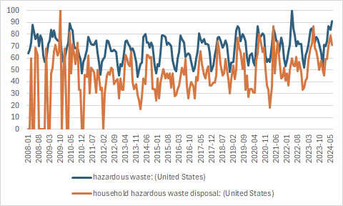

*“Hazardous waste” and “Household hazardous waste disposal” Frequencies (Google Trends, 2024)*

In searching for household hazardous waste disposal days for the pacific northwest, I found a link between the summer months and household hazardous waste disposal days (EvoGov.com, Free hazardous waste drop-off event, Free household hazardous waste disposal at Fort Hall Mine Landfill, Upcoming collection events, Wilson, S., 2024). It appears that events start as early as March and go through November depending upon location. In Pocatello, Idaho, there is an advertisement showing drop-offs happen between April and October (Free household hazardous waste disposal at Fort Hall Mine Landfill). The longest drop-off times I found were in Columbia county, Oregon (EvoGov.com). There are drop off days from March to November for Columbia county (EvoGov.com). Meanwhile in Douglas county Washington, there were drop off days in April and August (Upcoming collection events). And in Canyon county Idaho there was a single event posted in the month of June (Wilson, S., 2024).

With these drop-off days occurring in the spring and summer, we may assume that the weather affects people's motivation to clean houses and properly dispose of their hazardous items. If someone were to clean their home or garage in the winter and needed to dispose of dangerous items, the inclement weather may discourage this. Most places have better weather conditions in spring and summer, encouraging people to be outside; meanwhile, in the winter, people can be affected by seasonal depression. Cities and hazardous waste facilities seem to know this and schedule accordingly.

The next item to consider is whether or not there is a connection between peak search times of household hazardous waste disposal and hazardous waste exposure. In order to theorize about this, we will look at household hazardous waste disposal days and see if each hazardous waste constituent we have chosen aligns with peak searches. Figure 3 shows the searches for "household hazardous waste disposal" and "lead exposure." Figure 4 shows the searches for "household hazardous waste disposal" and "mercury exposure," and Figure 5 shows the searches for "household hazardous waste disposal" and "pesticide exposure."

Figure 3

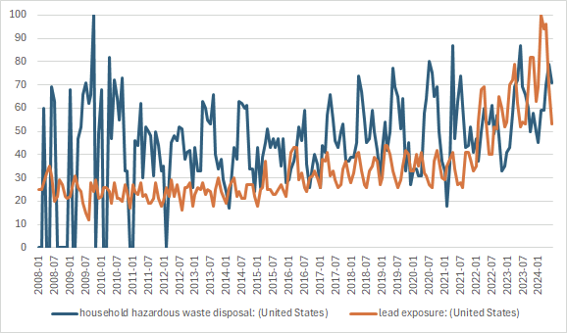

*“Household hazardous waste disposal” and ”lead exposure” searches (Google Trends, 2024)*

When searching Google Trends for “lead poisoning symptoms,” there are two distinguished peaks above the baseline, one in January 2016 and one in February 2024 (Google Trends). This tentatively refutes our hypothesis that household hazardous waste days encourage people to search for symptoms of exposure to lead. Most household hazardous waste disposal happens in the summer, and January and February are winter months. This does not necessarily rule out a correlation by itself, but it does support the idea that there is no connection. We should narrow our scope to the Pacific Northwest where we searched for household hazardous waste disposal days. In this narrowed field there is still no correlation between the summer months and peak searches, there are peaks happening throughout the year in any given month in different years (Google Trends).

Figure 4

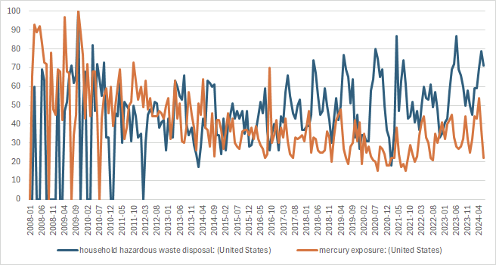

*“Household hazardous waste disposal” and ”mercury exposure” searches (Google Trends, 2024)*

In searching for a correlation between "mercury poisoning symptoms" and household hazardous waste disposal days, there is no overlap in the most significant peaks with the summer months (Google Trends). Both prominent peaks from 2008 to 2024 occur in December or January (Google Trends). Similarly to lead poisoning symptoms, this information does not support our hypothesis but actively refutes it. We have yet to rule out household hazardous waste disposal days, as the searches we have done are for household hazardous waste disposal days in the Pacific Northwest, and symptoms searches were in the total of the United States (Google Trends). When searching specifically in the Pacific Northwest, there are peaks in January, February, May, June, November, and December (Google Trends).

Our assumption that weather affects household hazardous waste disposal days seems likely, with the data showing a correlation between disposal days and time of the year. Meanwhile, the assumption that household hazardous waste disposal days increase awareness of exposure to hazardous constituents is not likely. This lack of correlation between exposure and household hazardous waste days may be due to a delayed onset of exposure symptoms or household hazardous waste days are not raising exposure awareness.

Figure 5

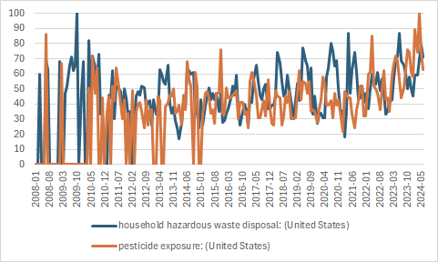

*“Household hazardous waste disposal” and “pesticide exposure” searches (Google Trends, 2024)*

Looking at "pesticide poisoning symptoms" searches in the Pacific Northwest, we see searches happen in March, June, July, August, and November (Google Trends). When we take this search to the entire US, it does look more like searches happen in the summer months (Google Trends). That is not to say there are no searches in the winter; however, there are just a few (Google Trends). With a narrow focus on pesticide poisoning symptoms in the Pacific Northwest and United States, we get a small amount of support for our hypothesis that household hazardous waste disposal days cause an increase in public awareness about hazardous waste exposure.

We must remember that even though pesticide poisoning symptoms peak in the summer months, it may not be due to household hazardous waste disposal days. When the weather is nice, people work on their yards to keep them looking nice. When working in the yard, people do not want weeds growing there or bugs eating their plants, so they may use herbicides or pesticides to manage these issues. So, while there is a correlation between household hazardous waste days and pesticide exposure symptoms searches, it's not indicative of causation.

Each of these searches can show us a limited window of popularity with the public. We can see when most searches happen and whether or not the frequency with which they occur matches up. These searches can provide insight into whether there is a potential link between each search item or if they are unrelated searches. Further research into when household hazardous waste disposal days occur in each state is necessary, as the Pacific Northwest is a small sample size. Additional research is also needed into the unique symptoms or combination of symptoms and their search frequency around household hazardous waste disposal days.

As noted, the household hazardous waste days are not limited to the Pacific Northwest. There are hazardous waste sites nationwide that can dispose of hazardous household waste. Figure 6 shows a map of the lower 48 states and the location of TSDF sites; TSDF stands for treatment storage and disposal facilities (EPA Facility Registry Service, 2020). These sites commonly host community days and open to the public for household hazardous waste disposal. These household hazardous waste days encourage proper disposal of household chemicals. There have even been instances of police departments bringing in the remnants meth labs these days, this is not common, and usually, the sites will not accept commercial or business wastes.

Figure 6

*A map of the United States showing all TSD facilities (EPA, 2024).*

There is not enough evidence to support household hazardous waste days encouraging the public to look at whether or not they have exposure to the hazards we have picked to examine in this topic. Pesticide poisoning symptoms searches might have some evidence supporting its correlation with household hazardous waste disposal days, but we should take that search overlap with caution. People typically do not use pesticides as often in the winter so that would necessitate most searches would occur outside that window. That exclusion requires that the searches correlate with the summer popularity of household hazardous waste disposal days.

    The assumptions we have made in this report are as follows:

* Search frequency correlates with increased awareness of proper hazardous waste disposal.
* The weather affects the public’s hazardous waste disposal motivation.
* Someone searching for hazardous constituent exposure symptoms may have been informed about the symptoms through hazardous waste exposure days.

I do not believe there are ethical concerns with this project. It does not rely on personal information; we make assumptions and inferences based on search patterns. The searches by individuals do not contain their personal information and do not infringe on their privacy. It is also not a sensitive subject or sensitive information.

The challenges with this project are that it is purely based on public searches, and there is no medical information that we can look at. If health data is made public and anonymity is preserved we would be able to make better inferences and see correlations that we cannot with public data (El et. all 2015). There have not been questionnaires that people can fill out to show the relationships between the data. Some of the searches have also narrowed down to only include the PNW, as the data from the whole US was too cumbersome. Going forward, expanding our search radius and trying to find anonymous health data for hazardous constituent exposure would be helpful.

Overall, we can see there is a correlation between household hazardous waste searches and hazardous waste searches. The correlation could imply a link between household hazardous waste days and knowledge of hazardous waste. The link between household hazardous waste search and hazardous constituent exposure is tenuous. The link between these two comes from the search history, and the history does not support the idea that household hazardous waste days spread awareness about hazardous constituent exposure. In the following figures we can see the data follow the same trends for increasing searches in the summer shown in Figure 7, but theoretically that exposure to lead is most frequent during the winter months opposite of household hazardous waste days as shown in Figure 8 where the peaks of each set of data occur opposite of each other by date (Google Trends).

Figure 7

.

*“Household hazardous waste disposal” and “hazardous waste” searches from 2008 to present (Google Trends, 2024)*

Figure 8

*“Household hazardous waste disposal” and “lead exposure” searches 2008 to present (Google Trends, 2024)*

It is unclear from the current data if there is an impact of "Household Hazardous Waste Days" on public knowledge of Hazard Waste or the resulting illnesses of exposure

* *"Household Hazardous Waste Disposal" and "Hazardous Waste" align very neatly.*
* *"Household Hazardous Waste Disposal" and "Lead Exposure" do not align with each other.*
* *"Hazardous Waste" and "Lead Exposure" searches align almost perfectly.*

These three points beg the question of why the transitive property is not in play. If A + B = C and B + D =C, why is A = D not true? That is to say, if the first and last thing have the same result of being true, and only one variable changed and gave us the same result of true, then why doesn't the variable that changed equal the same thing as the first variable? It means that there must be another variable in play. To answer this question, we will need to look for more data.

References

El Emam, K., Rodgers, S., & Malin, B. (2015, March 20). *Anonymising and sharing individual patient data*. BMJ (Clinical research ed.). https://www.ncbi.nlm.nih.gov/pmc/articles/PMC4707567/

Environmental Protection Agency. (n.d.). EPA. https://www.epa.gov/hw/defining-hazardous-waste-listed-characteristic-and-mixed-radiological-wastes

*EPA Facility Registry Service - RCRA hazardous waste treatment, storage, and disposal (RCRA TSD)*. ArcGIS Hub. (n.d.). https://hub.arcgis.com/datasets/EPA::epa-facility-registry-service-rcra-hazardous-waste-treatment-storage-and-disposal-rcra-tsd/explore?location=36.511041%2C-94.105926%2C4.74

EvoGov.com. (n.d.). *Household hazardous waste collection events*. Columbia County, Oregon Official Website - Household Hazardous Waste Collection Events. https://www.columbiacountyor.gov/departments/SolidWaste/HHW-Schedule

*Free hazardous waste drop-off event*. Free Hazardous Waste Drop-Off Event | Newberg Oregon. (n.d.). https://www.newbergoregon.gov/citymanager/page/free-hazardous-waste-drop-event

*Free household hazardous waste disposal at Fort Hall Mine Landfill*. East Idaho News. (n.d.). https://www.eastidahonews.com/calendar/free-household-hazardous-waste-disposal-at-fort-hall-mine-landfill-2023-04-01/

Google. (n.d.). Google trends. <https://trends.google.com/trends/>

*Upcoming collection events*. Upcoming Collection Events | Douglas County, WA. (n.d.). https://www.douglascountywa.net/443/Collection-Events

Wilson, S. (2024, May 30). *Free Hazardous Waste & Electronic Waste Disposal event in Canyon County*. Idaho News 6 Boise Twin Falls (KIVI). https://www.kivitv.com/caldwell/free-hazardous-waste-electronic-waste-disposal-event-in-canyon-county